Lab Report

Name: | Thomas Farrell
Student Number: | 20083540
Lab (Week) Number: | 01
Date: | 11/09/2024

Exercise 03.1
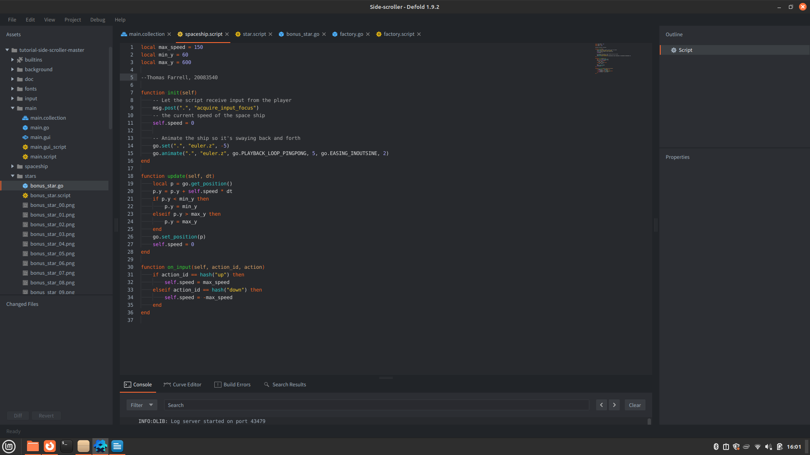
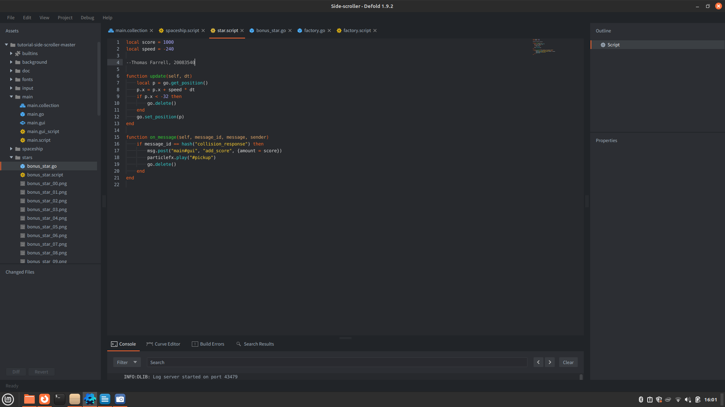
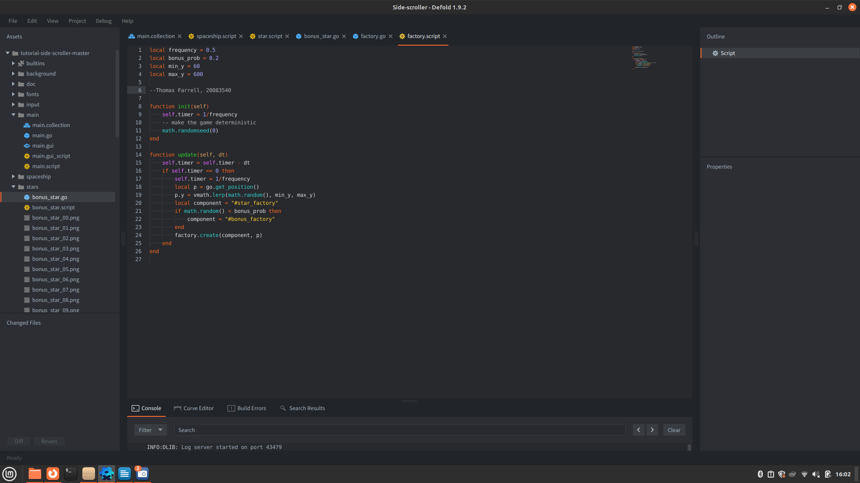

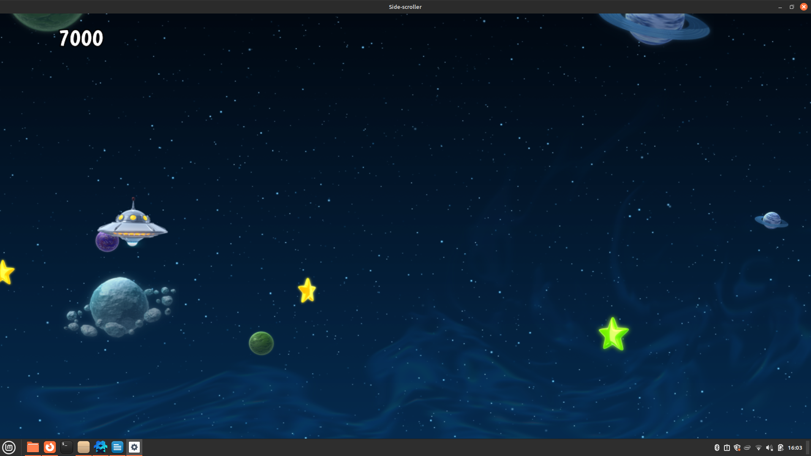

Exercise 04.1

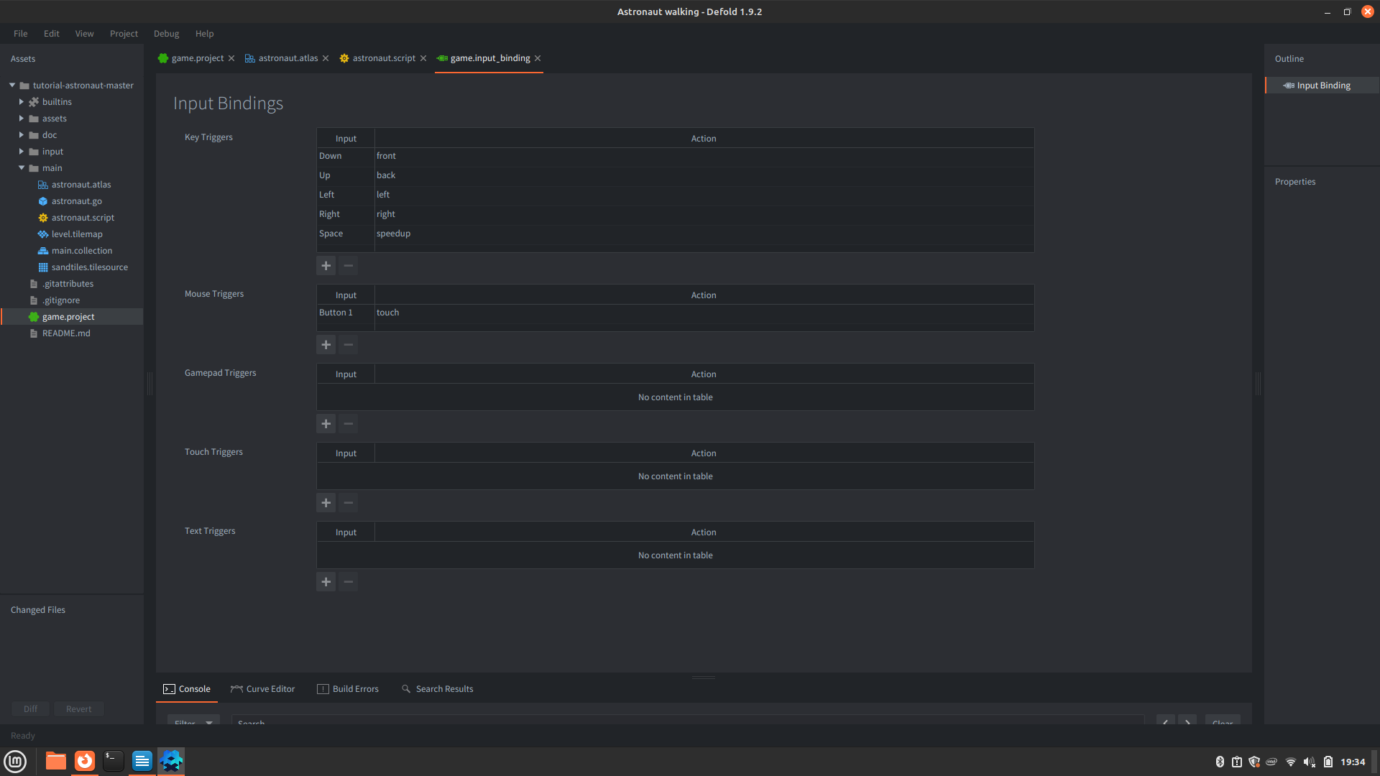

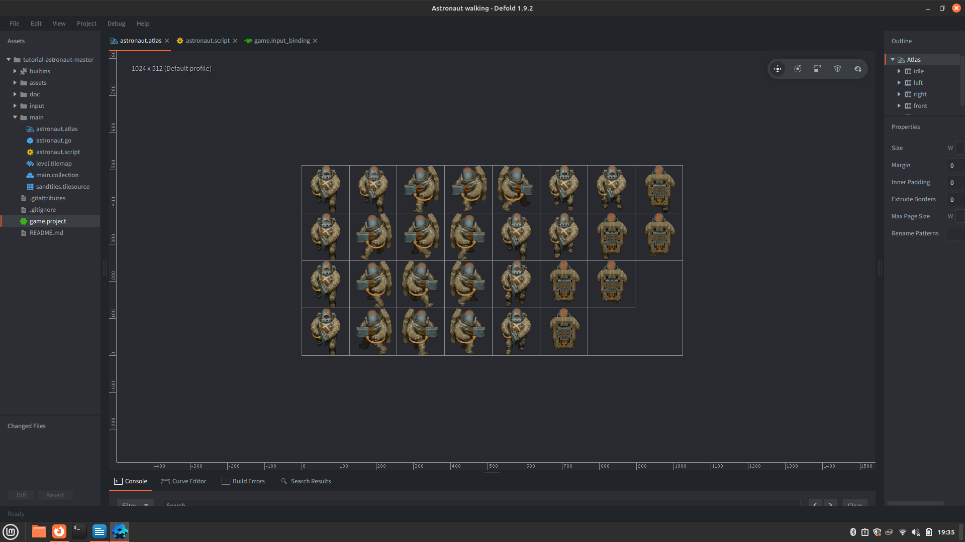

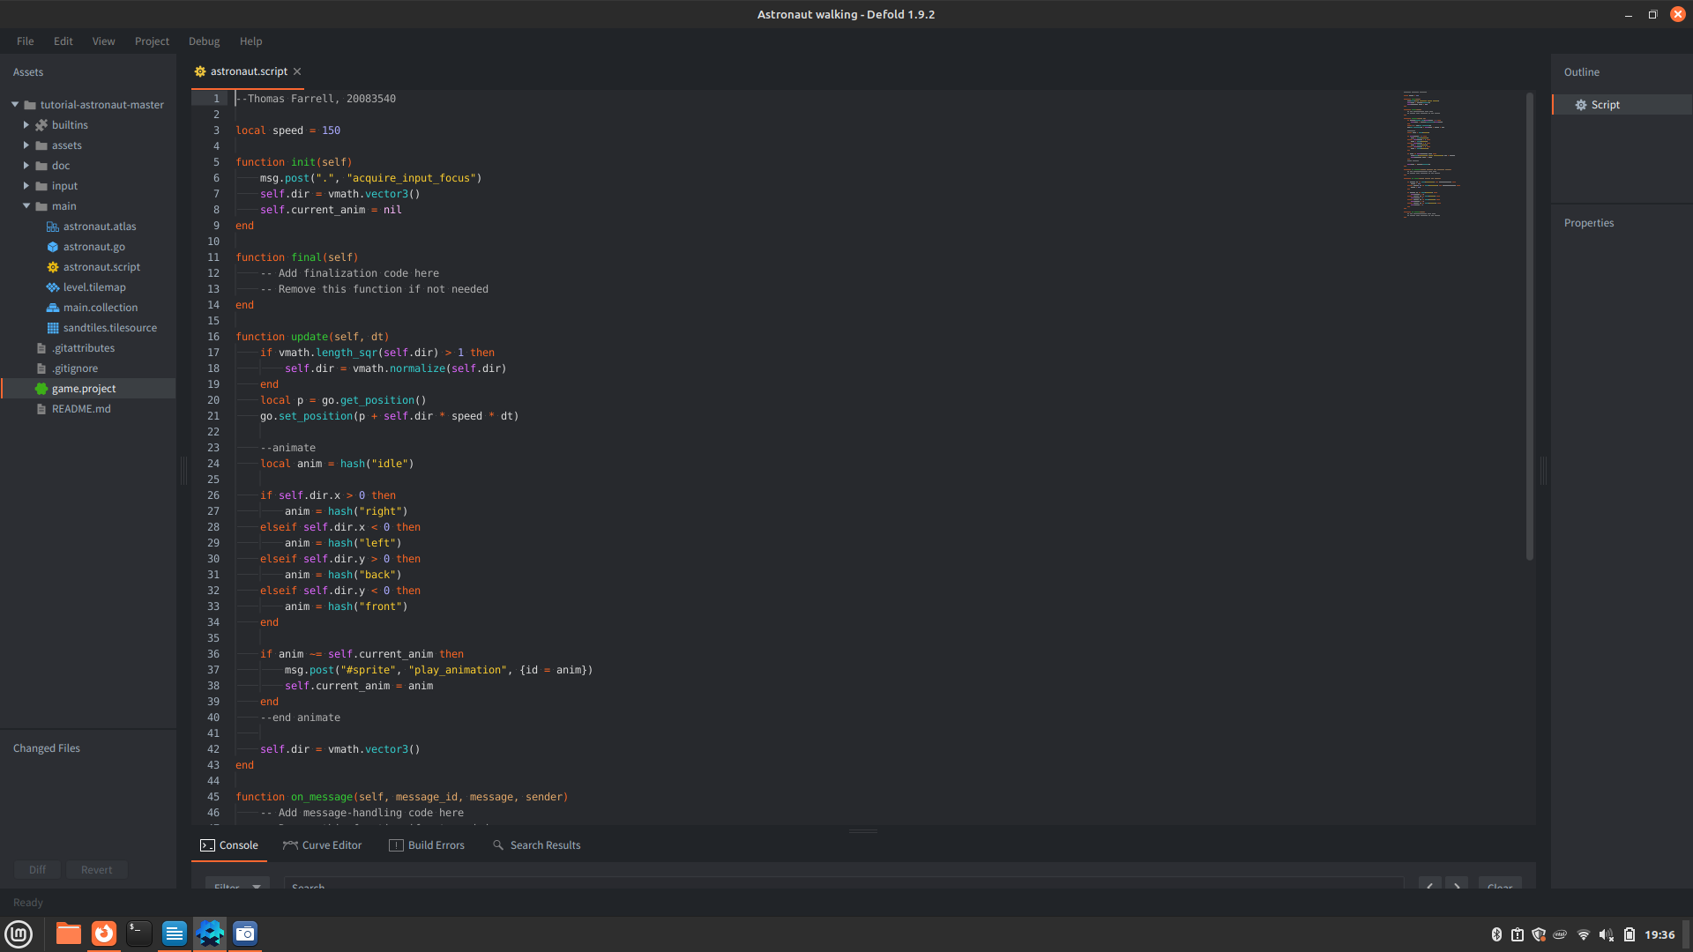

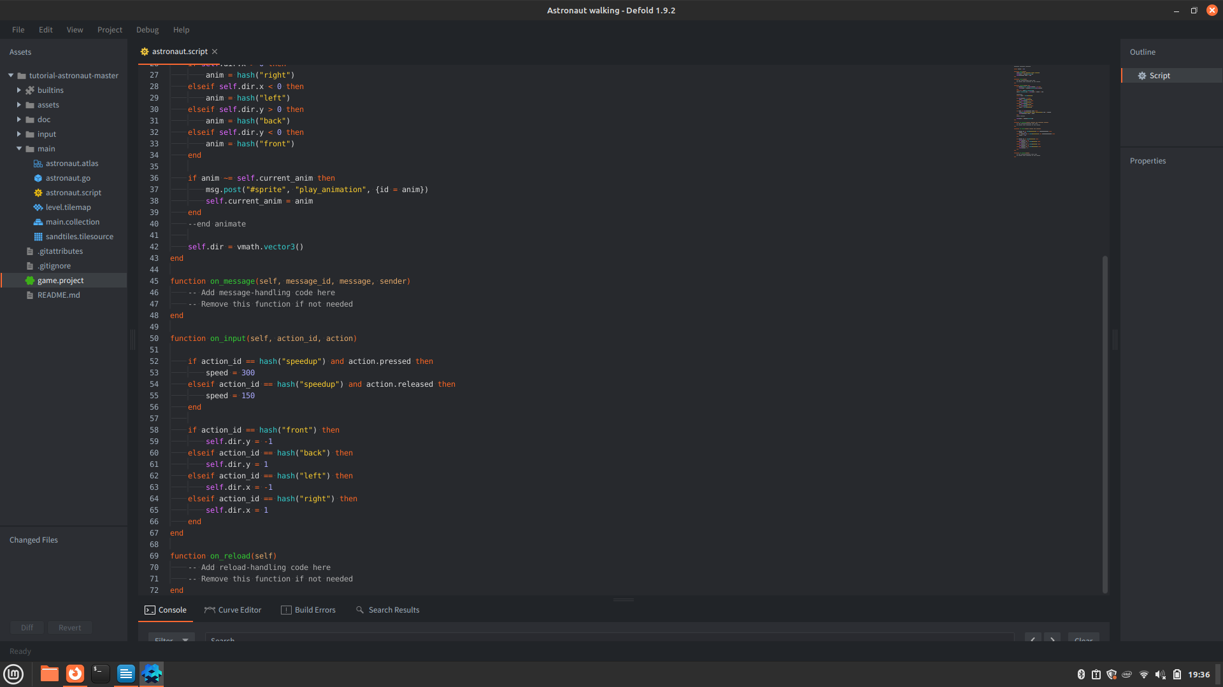

Conclusions (optional)
The game engine itself is exceptionally lightweight, which makes sense since it has compatibility with hardware going back a few decades. The small amount of Lua I’ve seen during these two tutorials is much more rudimenary than I expected; though I expect that to change at a rapid pace.

Looking forward to learning more of Lua, as I know that it’s also heavily used in many modding communities, such as Skyrim, CyberPunk 2077 and even Final Fantasy 14.

